JAMES BRESCIANI

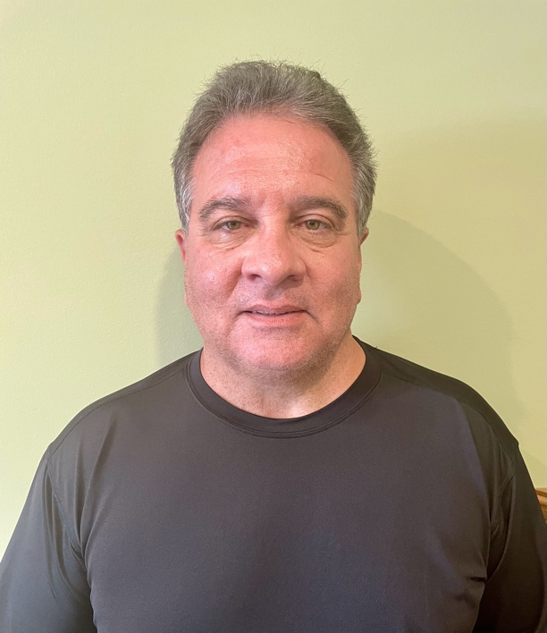

ABOUT

HEIGHT: 5’6”
WEIGHT: 210 lbs
HAIR: DARK BROWN (with salt and pepper grey)
BUILD: HUSKY

BACKGROUND

I am a retired teacher / school principal. I became involved with acting after I retired, when they were filming a crime documentary in the city. I was selected to play supporting roles in two episodes of “I Lived With A Killer.” I am very interested in doing some more acting.

ACTING HISTORY

2018 Actor – “I Lived with a Killer”, Season 1, episode 12 Portrayed Greg Scarpa
2018 Actor – “I Lived with a Killer”, Season 1, episode 20 Portrayed Seddique Mateen

ADDITIONAL INFORMATION

I owned, raised and trained horses and can ride – western and bareback.

AGENT: Radiant StarZ

